NOTIFIABLE MEDICAL CONDITIONS SURVEILLANCE SYSTEM

the National Institute for Communicable Diseases

Table of Contents

Introduction 5

0.1 HIGHLIGHTS 5

0.2 NMC Reporting Application 5

1 NMC data summary, June 2023 6

1.0.1 Hospital Form Complete 11

1.0.2 Distribution of category 1 NMCs by province and number of deaths, 12

1.0.3 Distribution of category 2 NMCs by province and number of deaths, 14

1.0.4 The average active users on the NMC App 16

1.0.5 Data quality 17

1.0.6 Malaria Analysis 21

1.0.7 Malaria addition 23

1.0.8 Tables 23

1.0.9 Maps 26

We need to make titels etc relative, for instance, if this is the June report, there needs to be an object name that chnages for the sys.date()

Scripts need to run within the document

The document needs to be converted to quarto.

Need to include logo on the first page.

# Introduction

This report summarizes data from the National Notifiable Medical Conditions Surveillance System (NMCSS) on cases diagnosed and reported in **June 2023**. Additionally, this report includes information on the distribution of case notifications by sources, such as clinical or laboratory notifications, merged cases (**see Appendix no. 3**), and the number of reported deaths. It monitors the use of the electronic NMC Reporting Application (App) for notification, data quality, specifically the completeness and timeliness of clinical diagnosis and notifications over time, and back-captured cases notified in March (**see Appendix nos. 1 and 3**). Category 4 NMCs and multi-system inflammatory syndrome (MIS-C) have been excluded from this report.

## HIGHLIGHTS

* A total of 7539 cases were notified in June 2023 and the majority were category 2 conditions.
* There were x average active users of the NMC App in June 2023
* Category 1 cases were reported in median (IQR) of days.

## NMC Reporting Application

* NMC Reporting App is available on both web and mobile platforms
* Use recommended browsers in order to access NMC reporting App for notifications, searching of cases and reports.
* Register if you have no NMC account and you can reset the password if you have not used the application over 12 months.

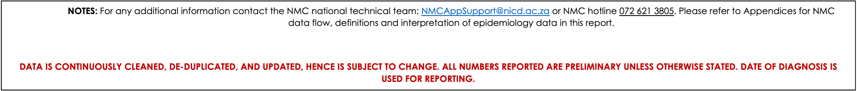

#### 1 NMC data summary, June 2023

A total of 8029 cases were diagnosed and notified to the NMCSS in June 2023. There were 7539 current notifications and 490 back captured notifications (**see Appendix no.3 for definitions**). The majority were category 2 conditions n(%) 6,358 (84%). The provinces with the highest number of notifications were KwaZulu-Natal (n=1993, 24.8%), Western Cape (n=1369, 17.1%)), Gauteng (n=2083,25.9%). The provinces with the least number of notifications were Northern Cape (n=379, 4.7%) and North West (n=251, 3.1%). (**Figure 1**) There were 490 back captured clinical notifications diagnosed between December, 2019 and June 2023and only notified in June 2023. The majority of those notifications were n(%)88 (66%) TB cases(**See Appendix no.1**).

Table 1.1: Description of NMC notifications by case source

| **Characteristic** | **Overall**, N = 7,5391 | **Clinical**, N = 5035 (67%)1 | **Lab**, N = 2237 (30%)1 | **Merged**, N = 267 (3.5%)1 |
| --- | --- | --- | --- | --- |
| NMC Category |  |  |  |  |
| Category 1 | 1,056 (14%) | 438 (8.7%) | 464 (21%) | 154 (58%) |
| Category 2 | 6,358 (84%) | 4,597 (91%) | 1,660 (74%) | 101 (38%) |
| Category 3 | 125 (1.7%) | 0 (0%) | 113 (5.1%) | 12 (4.5%) |
| 1n (%) | | | | |

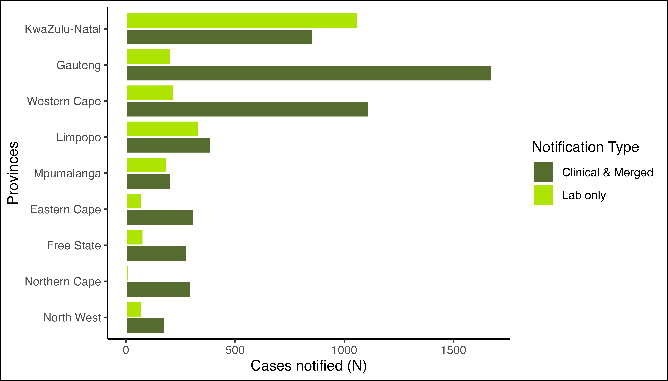

Figure 1.1: Distribution of notifications by province and notification type

There were 546 (10%) Clinical notifications from from the private sector (i.e. private hospitals, private practice and mining industry) compared to 4,756 (90%) in the public sector. The majority of the clinical notifications were captured using the NMC Reporting Application (see Table 2).

Table 1.2: Clinical notifications notified by provinces, reporting platform, and sector

| **Characteristic** | **Overall**, N = 5,3021 | **App - Private**, N = 5361 | **App - Public**, N = 4,7131 | **Paper-based - Private**, N = 101 | **Paper-based - Public**, N = 431 |
| --- | --- | --- | --- | --- | --- |
| Province |  |  |  |  |  |
| EC | 310 (100%) | 38 (12%) | 267 (86%) | 0 (0%) | 5 (1.6%) |
| FS | 279 (100%) | 39 (14%) | 236 (85%) | 3 (1.1%) | 1 (0.4%) |
| GP | 1,676 (100%) | 195 (12%) | 1,476 (88%) | 2 (0.1%) | 3 (0.2%) |
| KZN | 857 (100%) | 72 (8.4%) | 785 (92%) | 0 (0%) | 0 (0%) |
| LP | 389 (100%) | 31 (8.0%) | 353 (91%) | 0 (0%) | 5 (1.3%) |
| MP | 205 (100%) | 30 (15%) | 167 (81%) | 1 (0.5%) | 7 (3.4%) |
| NC | 295 (100%) | 14 (4.7%) | 275 (93%) | 0 (0%) | 6 (2.0%) |
| NW | 176 (100%) | 51 (29%) | 117 (66%) | 0 (0%) | 8 (4.5%) |
| WC | 1,114 (100%) | 66 (5.9%) | 1,037 (93%) | 3 (0.3%) | 8 (0.7%) |
| Unknown | 1 | 0 | 0 | 1 | 0 |
| 1n (%) | | | | | |

(#tab:tbl_desc)Age distribution by gender, admission status, and patient outcome

|  | **Gender** | | **Admission Status** | | | | | **Vital Status** | | | **Overall** |
| --- | --- | --- | --- | --- | --- | --- | --- | --- | --- | --- | --- |
| **Characteristic** | **Female**1 | **Male**1 | **Discharged**1 | **Inpatient**1 | **Outpatient**1 | **Transferred**1 | **Unknown**1 | **Alive**1 | **Deceased**1 | **Unknown**1 | **N = 7,539**2 |
| Age Category |  |  |  |  |  |  |  |  |  |  |  |
| 0-4 | 221 | 263 | 24 | 223 | 134 | 10 | 4 | 387 | 6 | 3 | 484 (6.4%) |
| 5-9 | 188 | 258 | 35 | 107 | 92 | 1 | 4 | 229 | 4 | 5 | 446 (5.9%) |
| 10-14 | 144 | 343 | 20 | 58 | 75 | 0 | 2 | 151 | 2 | 2 | 487 (6.5%) |
| 15-19 | 151 | 281 | 11 | 38 | 149 | 2 | 8 | 204 | 1 | 2 | 432 (5.7%) |
| 20-24 | 263 | 245 | 25 | 93 | 205 | 4 | 5 | 326 | 2 | 5 | 508 (6.7%) |
| 25-29 | 290 | 310 | 38 | 150 | 276 | 4 | 7 | 466 | 4 | 3 | 600 (8.0%) |
| 30-34 | 379 | 435 | 45 | 199 | 354 | 3 | 10 | 599 | 6 | 5 | 814 (11%) |
| 35-39 | 353 | 519 | 40 | 230 | 364 | 8 | 12 | 633 | 15 | 5 | 872 (12%) |
| 40-44 | 292 | 475 | 47 | 196 | 324 | 7 | 12 | 560 | 15 | 10 | 767 (10%) |
| 45-49 | 186 | 339 | 20 | 155 | 242 | 8 | 4 | 412 | 10 | 6 | 525 (7.0%) |
| 50-54 | 148 | 256 | 24 | 106 | 197 | 5 | 6 | 327 | 4 | 2 | 404 (5.4%) |
| 55-59 | 123 | 234 | 25 | 126 | 150 | 3 | 6 | 300 | 7 | 2 | 357 (4.7%) |
| 60-64 | 103 | 150 | 20 | 91 | 106 | 2 | 5 | 220 | 1 | 4 | 253 (3.4%) |
| 65+ | 149 | 182 | 30 | 138 | 121 | 5 | 6 | 284 | 10 | 5 | 331 (4.4%) |
| Unknown | 118 | 141 | 1 | 24 | 8 | 0 | 3 | 30 | 0 | 3 | 259 (3.4%) |
| 1n | | | | | | | | | | | |
| 2n (%) | | | | | | | | | | | |

The majority of the notified cases were Males n(%) 4,431 (59%). Individuals in the Unknown year age group represented the majority (94 (1.8%)) of notified cases (Table x). At the time of notificaiton, approximately 1,934 (37%) of the notified cases were hospitalized, while 62 (1.2%) were transferred to another healthcare facility. There were 87 deaths notified during the reporting period with case fatality rate of 1.6%.

check in table @ref(tab:tbl_desc)

### 1.0.1 Hospital Form Complete

| **Characteristic** | **No**, N = 1,9901 | **Yes**, N = 4111 |
| --- | --- | --- |
| patient_admission_status |  |  |
| Discharged | 378 (19%) | 27 (6.6%) |
| Inpatient | 1,552 (78%) | 382 (93%) |
| Transferred | 60 (3.0%) | 2 (0.5%) |
| 1n (%) | | |

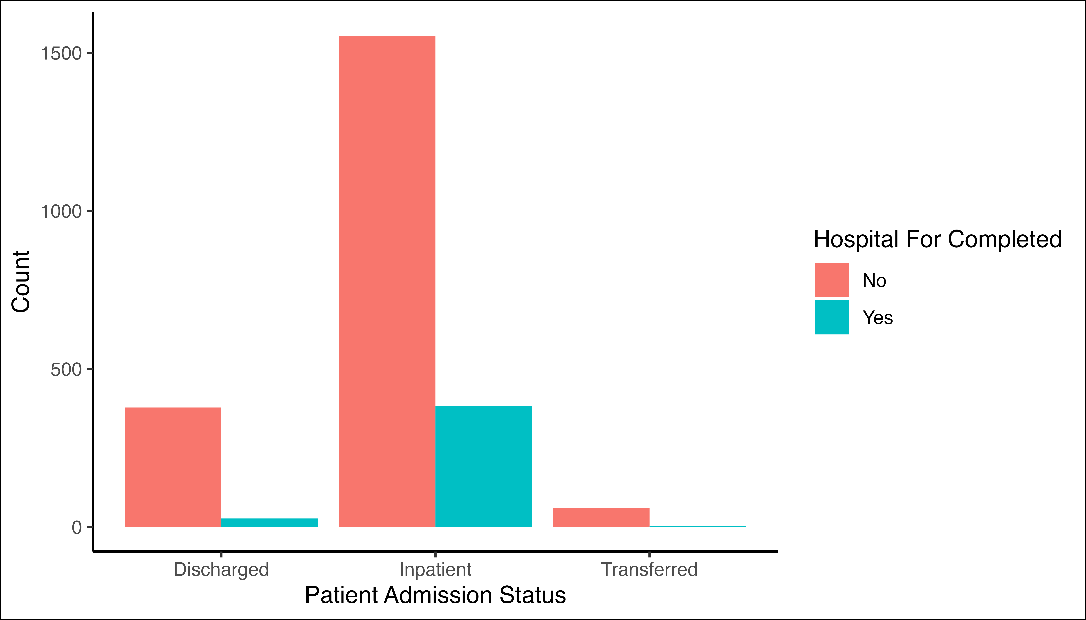

Figure 1.2: Completion of hospitalisation form for patients diagnosed with category 1 conditions who were either admitted, discharged, or transferred out

### 1.0.2 Distribution of category 1 NMCs by province and number of deaths,

## [1] NA "14 (1.3%)" "1 (<0.1%)" "167 (16%)" "5 (0.5%)" "7 (0.7%)"   
## [7] "12 (1.1%)" "7 (0.7%)" "6 (0.6%)" "493 (47%)" "59 (5.6%)" "27 (2.6%)"  
## [13] "237 (22%)" "3 (0.3%)" "20 (1.9%)"

## [1] 232

Table 1.3: Age distribution by gender, admission status, and patient outcome

|  | **Provinces** | | | | | | | | | **Vital Status** | |
| --- | --- | --- | --- | --- | --- | --- | --- | --- | --- | --- | --- |
| **Characteristic** | **EC**1 | **FS**1 | **GP**1 | **KZN**1 | **LP**1 | **MP**1 | **NC**1 | **NW**1 | **WC**1 | **Not Deceased**2 | **Deceased**2 |
| Condition |  |  |  |  |  |  |  |  |  |  |  |
| Acute Flaccid Paralysis | 2 | 0 | 3 | 3 | 1 | 2 | 0 | 0 | 3 | 14 (100%) | 0 (0%) |
| Acute rheumatic fever | 0 | 0 | 0 | 1 | 0 | 0 | 0 | 0 | 0 | 1 (100%) | 0 (0%) |
| Cholera | 0 | 8 | 84 | 0 | 31 | 42 | 0 | 2 | 0 | 161 (96%) | 6 (3.6%) |
| Congenital rubella syndrome | 1 | 1 | 0 | 2 | 0 | 0 | 0 | 0 | 1 | 5 (100%) | 0 (0%) |
| Diphtheria | 0 | 3 | 1 | 0 | 0 | 0 | 0 | 0 | 3 | 7 (100%) | 0 (0%) |
| Enteric fever (typhoid or paratyphoid fever) | 0 | 0 | 6 | 0 | 0 | 0 | 0 | 0 | 6 | 12 (100%) | 0 (0%) |
| Food borne illness outbreak | 5 | 0 | 0 | 0 | 1 | 0 | 0 | 0 | 1 | 7 (100%) | 0 (0%) |
| Listeriosis | 0 | 0 | 0 | 0 | 1 | 0 | 0 | 0 | 5 | 6 (100%) | 0 (0%) |
| Malaria | 6 | 8 | 102 | 33 | 232 | 67 | 5 | 13 | 27 | 490 (99%) | 4 (0.8%) |
| Measles | 1 | 1 | 8 | 12 | 25 | 8 | 0 | 0 | 4 | 59 (100%) | 0 (0%) |
| Meningococcal Disease | 2 | 0 | 6 | 2 | 0 | 0 | 2 | 1 | 14 | 23 (85%) | 4 (15%) |
| Pertussis | 13 | 34 | 84 | 30 | 15 | 17 | 3 | 14 | 27 | 233 (98%) | 4 (1.7%) |
| Rabies | 1 | 0 | 0 | 0 | 2 | 0 | 0 | 0 | 0 | 2 (67%) | 1 (33%) |
| Rubella | 1 | 7 | 4 | 2 | 3 | 0 | 0 | 2 | 1 | 20 (100%) | 0 (0%) |
| 1n | | | | | | | | | | | |
| 2n (%) | | | | | | | | | | | |

The majority of category 1 notifications were for n(%) . The majority of cases were notified in LP n(%) (21.9.

### 1.0.3 Distribution of category 2 NMCs by province and number of deaths,

A total of 68454 658 NMC category 2 notifications were diagnosed in . The majority of category 2 NMC notifications were pulmonary tuberculosis infection (52.1%) followed by Bilharzia (24.1%) and Hepatitis B (18.5%). Thirty-nine deaths were reported due to pulmonary tuberculosis infection.

Table 1.4: Distribution of Category 2 NMC by Province

|  | **Provinces** | | | | | | | | | **Vital Status** | |
| --- | --- | --- | --- | --- | --- | --- | --- | --- | --- | --- | --- |
| **Characteristic** | **EC**1 | **FS**1 | **GP**1 | **KZN**1 | **LP**1 | **MP**1 | **NC**1 | **NW**1 | **WC**1 | **Not Deceased**2 | **Deceased**2 |
| Condition |  |  |  |  |  |  |  |  |  |  |  |
| Agricultural or stock remedy poisoning | 1 | 12 | 29 | 0 | 2 | 1 | 0 | 2 | 4 | 47 (92%) | 4 (7.8%) |
| Bilharzia (schistosomiasis) | 17 | 0 | 30 | 492 | 125 | 112 | 0 | 1 | 27 | 804 (100%) | 0 (0%) |
| Brucellosis | 2 | 0 | 0 | 0 | 0 | 0 | 0 | 1 | 1 | 4 (100%) | 0 (0%) |
| Congenital syphilis | 0 | 1 | 1 | 10 | 0 | 1 | 0 | 0 | 9 | 20 (91%) | 2 (9.1%) |
| Haemophilus influenzae type B | 1 | 0 | 2 | 1 | 1 | 1 | 2 | 0 | 0 | 8 (100%) | 0 (0%) |
| Hepatitis A | 17 | 15 | 87 | 41 | 29 | 22 | 7 | 9 | 158 | 384 (100%) | 1 (0.3%) |
| Hepatitis B | 18 | 37 | 41 | 617 | 8 | 15 | 5 | 51 | 16 | 806 (100%) | 2 (0.2%) |
| Hepatitis C | 0 | 1 | 5 | 0 | 0 | 0 | 0 | 0 | 0 | 6 (100%) | 0 (0%) |
| Legionellosis | 0 | 0 | 0 | 0 | 0 | 0 | 0 | 0 | 7 | 6 (86%) | 1 (14%) |
| Maternal death (pregnancy, childbirth and puerperium) | 0 | 0 | 1 | 0 | 0 | 0 | 0 | 0 | 0 | 0 (0%) | 1 (100%) |
| Soil transmitted helminths | 0 | 0 | 3 | 0 | 0 | 0 | 0 | 0 | 0 | 3 (100%) | 0 (0%) |
| Tetanus | 0 | 0 | 0 | 0 | 0 | 0 | 0 | 0 | 1 | 1 (100%) | 0 (0%) |
| Tuberculosis: extensively drug -resistant (XDR -TB) | 1 | 0 | 2 | 2 | 0 | 0 | 1 | 0 | 1 | 7 (100%) | 0 (0%) |
| Tuberculosis: multidrug- resistant (MDR -TB) | 9 | 3 | 16 | 45 | 6 | 5 | 2 | 5 | 25 | 114 (98%) | 2 (1.7%) |
| Tuberculosis:extra-pulmonary | 35 | 46 | 468 | 135 | 56 | 18 | 39 | 25 | 170 | 974 (98%) | 18 (1.8%) |
| Tuberculosis:pulmonary | 251 | 193 | 1,079 | 556 | 227 | 91 | 313 | 124 | 796 | 3,586 (99%) | 44 (1.2%) |
| 1n | | | | | | | | | | | |
| 2n (%) | | | | | | | | | | | |

### 1.0.4 The average active users on the NMC App

*Insert chart from excel*

### 1.0.5 Data quality

#### 1.0.5.1 Completeness of clinical notifications in the NMerCSS,

Completeness refers to the proportion of complete data entries per variable in the dataset among clinical and merged notifications. In x 2023, there was an increase in completeness of date of diagnosis and patient folder number, while demographic details and patient vital status remain unchanged captured compared to x 2023.

Table 1.5: NMC data completeness on both reporting platforms,

| **Characteristic** | **App**, N = 4,9951 | **Paper-based**, N = 531 |
| --- | --- | --- |
| **Folder Number** | 4,995 (100%) | 53 (100%) |
| **First Name** | 4,995 (100%) | 53 (100%) |
| **Surname** | 4,995 (100%) | 53 (100%) |
| **Symptom Onset Date** | 4,981 (100%) | 53 (100%) |
| **Date of Diagnosis** | 4,995 (100%) | 53 (100%) |
| **Outcome** | 4,966 (99%) | 53 (100%) |
| 1n (%) | | |

#### 1.0.5.2 Timeliness of clinical notifications by NMC categories and province,

Timeliness is measured by the number of days from the time of diagnosis of the NMC to the time of notification. Overall, it took a median (IQR) of days to report category 1 NMCs.

Table 1.6: Time to Notification in days by NMC category.

| **Characteristic** | **1**, N = 1,0561 | **2**, N = 6,3581 | **3**, N = 1251 |
| --- | --- | --- | --- |
| Time to Notification | 1 (0, 2) | 3 (0, 9) | 4 (4, 6) |
| Unknown | 464 | 1,660 | 113 |
| 1Median (IQR) | | | |

###### 1.0.5.2.0.1 **Conclusion**

The majority of notifications were clinical notifications. The increase in average active users and newly registered users over time is an indication of an increase in the acceptance of the NMC App in the provinces. The completeness of patient clinical details and patient demographic details have improved, due to the application of mandatory fields on the NMC App. There was a delay in reporting tuberculosis cases. The data harmonization processes between the current and improved NMC system are underway to improve reporting.

###### 1.0.5.2.0.2 **Recommendations**

* We recommend the expedition of NMC App “whitelisting” on the provincial departmental intranet to make the electronic notification platform more accessible to health facilities.
* We recommend that clinicians should complete all patient clinical and demographic details to improve completeness.
* NMC Trainers to emphasize the importance of timeous reporting of Category 1 and 2 NMCs, in order to ensure real-time availability of data for public health action.
* We recommend public health interventions for Bilharzia and Malaria to be implemented to progress towards the elimination.

###### 1.0.5.2.0.3 **Appendix no.1: Back captured clinical notifications**

|  | **Overall** | **Province** | | | | | | | | |
| --- | --- | --- | --- | --- | --- | --- | --- | --- | --- | --- |
| **Characteristic** | **N = 133**1 | **EC**, N = 12 | **FS**, N = 132 | **GP**, N = 452 | **KZN**, N = 212 | **LP**, N = 132 | **MP**, N = 82 | **NC**, N = 102 | **NW**, N = 12 | **WC**, N = 212 |
| condition |  |  |  |  |  |  |  |  |  |  |
| Bilharzia (schistosomiasis) | 6 (4.5%) | 0 | 0 | 0 | 0 | 5 | 1 | 0 | 0 | 0 |
| Congenital syphilis | 1 (0.8%) | 0 | 0 | 0 | 1 | 0 | 0 | 0 | 0 | 0 |
| Hepatitis C | 1 (0.8%) | 0 | 0 | 1 | 0 | 0 | 0 | 0 | 0 | 0 |
| Malaria | 1 (0.8%) | 0 | 0 | 0 | 0 | 1 | 0 | 0 | 0 | 0 |
| Pertussis | 2 (1.5%) | 0 | 2 | 0 | 0 | 0 | 0 | 0 | 0 | 0 |
| Tuberculosis: multidrug- resistant (MDR -TB) | 6 (4.5%) | 0 | 0 | 1 | 3 | 0 | 1 | 0 | 0 | 1 |
| Tuberculosis:extra-pulmonary | 28 (21%) | 0 | 2 | 16 | 4 | 2 | 0 | 1 | 0 | 3 |
| Tuberculosis:pulmonary | 88 (66%) | 1 | 9 | 27 | 13 | 5 | 6 | 9 | 1 | 17 |
| 1n (%) | | | | | | | | | | |
| 2n | | | | | | | | | | |

## [1] "30 December, 2019"

###### 1.0.5.2.0.4 **Appendix no.2: Summary of NMCSS Data Flow**

|  |
| --- |
| **Figure 4**: Summary of data flow within the NMC surveillance system |

**Figure 4**: Summary of data flow within the NMC surveillance system

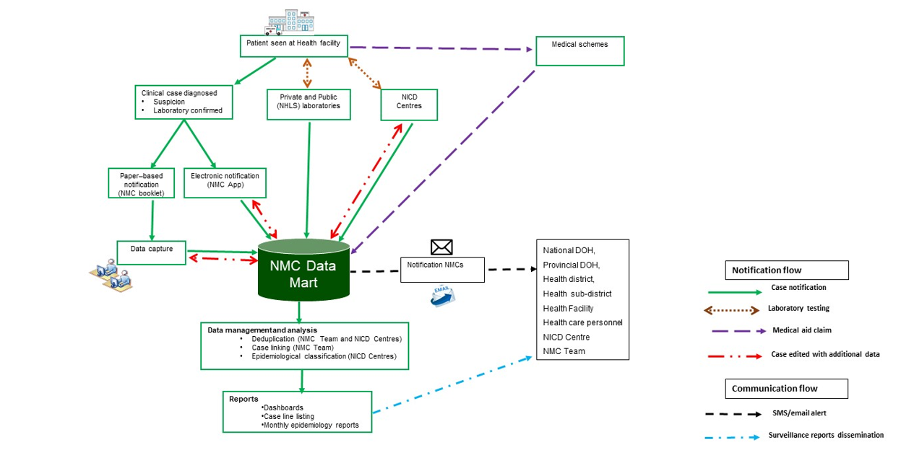

### 1.0.6 Malaria Analysis

###### 1.0.6.0.0.1 **Appendix 3: NMC Categories, and Case Classification definitions**

**NMC categories**

**Category 1**: NMCs notified by the most rapid means available upon diagnosis, followed by a written or electronic notification to the Department of Health within 24 hours of diagnosis by healthcare providers, private health laboratories or public health laboratories. These conditions must be notified based on clinical suspicion irrespective of laboratory confirmation.

**Category 2**: NMCs notified through a written or an electronic notification to the Department of Health of clinical or laboratory diagnosis within 7 days by healthcare providers, private health laboratories or public health laboratories.

**Category 3**: NMCs notified through a written or electronic notification to the Department of Health within 7 days of diagnosis by public and private health laboratories.

**Category 4**: NMCs notified through a written or electronic notification to the Department of Health within 1 month of diagnosis by public and private health laboratories.

**Case Classification definitions**

**Clinical case**: are cases reported to the NMC by health care providers at facilities, either through completion of a paper form that is faxed, emailed to National Institute of Communicable Diseases (NICD), or by direct data entry into the NMC application on a PC, laptop or mobile device. The diagnosis is made by the clinician on the basis of case definitions published on the NICD website.

**Laboratory case**: are cases that are downloaded into the NMC database directly from the National Health Laboratory Services (NHLS) laboratory information system. The NMC application applies the case definitions that are published on the NICD website. Private sector data is being sourced.

**Merged cases**: are cases where a case was notified by health care provider at the facility (a ‘clinical case’) AND the laboratory issued a report with a positive result for the same case (a ’laboratory case). The NMC App is set up to automatically detect and link clinical and laboratory case notifications. The NICD specialist Centres and NMC data team review all cases and manually link any remaining clinical and laboratory cases

**Notification capture times defintions**

**Current notification**: All cases diagnosed and notified in the current month

**Delayed notification**: All cases diagnosed in the last 14 days from the previous month

**Back capture notification**: All cases diagnosed in previous months and before the last 14 days of the previous month.

### 1.0.7 Malaria addition

### 1.0.8 Tables

Table 1.7: Distribution of Malaria notifications by District and year

| **Characteristic** | **2021**, N = 2,0771 | **2022**, N = 5,0601 | **2023**, N = 3,9591 |
| --- | --- | --- | --- |
| District |  |  |  |
| Alfred Nzo | 4 (0.2%) | 3 (<0.1%) | 9 (0.2%) |
| Amajuba | 7 (0.3%) | 10 (0.2%) | 5 (0.1%) |
| Amathole | 6 (0.3%) | 2 (<0.1%) | 2 (<0.1%) |
| Applicable Not Applicable | 1 (<0.1%) | 0 (0%) | 0 (0%) |
| Bojanala Platinum | 22 (1.1%) | 102 (2.0%) | 79 (2.0%) |
| Buffalo | 13 (0.6%) | 19 (0.4%) | 16 (0.4%) |
| Cape Town | 42 (2.0%) | 151 (3.0%) | 94 (2.4%) |
| Cape Winelands | 2 (<0.1%) | 14 (0.3%) | 9 (0.2%) |
| Capricorn | 56 (2.7%) | 113 (2.2%) | 119 (3.0%) |
| Chris Hani | 5 (0.2%) | 5 (<0.1%) | 0 (0%) |
| Dr Kenneth Kaunda | 13 (0.6%) | 52 (1.0%) | 18 (0.5%) |
| Dr Ruth Segomotsi Mompati | 2 (<0.1%) | 9 (0.2%) | 3 (<0.1%) |
| Eden | 11 (0.5%) | 26 (0.5%) | 15 (0.4%) |
| Ehlanzeni | 336 (16%) | 683 (13%) | 486 (12%) |
| Ekurhuleni | 80 (3.9%) | 398 (7.9%) | 222 (5.6%) |
| Ethekwini | 34 (1.6%) | 140 (2.8%) | 72 (1.8%) |
| Fezile Dabi | 6 (0.3%) | 8 (0.2%) | 0 (0%) |
| Frances Baard | 6 (0.3%) | 22 (0.4%) | 12 (0.3%) |
| Gert Sibande | 11 (0.5%) | 51 (1.0%) | 31 (0.8%) |
| Greater Sekhukhune | 23 (1.1%) | 89 (1.8%) | 46 (1.2%) |
| Harry Gwala | 0 (0%) | 4 (<0.1%) | 1 (<0.1%) |
| Ilembe | 15 (0.7%) | 78 (1.5%) | 19 (0.5%) |
| Joe Gqabi | 0 (0%) | 2 (<0.1%) | 1 (<0.1%) |
| Johannesburg | 117 (5.6%) | 447 (8.8%) | 219 (5.5%) |
| John Taolo Gaetsewe | 1 (<0.1%) | 2 (<0.1%) | 1 (<0.1%) |
| Lejweleputswa | 7 (0.3%) | 26 (0.5%) | 16 (0.4%) |
| Mangaung | 21 (1.0%) | 33 (0.7%) | 22 (0.6%) |
| Mopani | 392 (19%) | 508 (10%) | 672 (17%) |
| Namakwa | 0 (0%) | 3 (<0.1%) | 1 (<0.1%) |
| Nelson Mandela Bay | 16 (0.8%) | 38 (0.8%) | 13 (0.3%) |
| Ngaka Modiri Molema | 9 (0.4%) | 20 (0.4%) | 3 (<0.1%) |
| Nkangala | 28 (1.3%) | 128 (2.5%) | 39 (1.0%) |
| O R Tambo | 12 (0.6%) | 16 (0.3%) | 8 (0.2%) |
| Overberg | 2 (<0.1%) | 11 (0.2%) | 3 (<0.1%) |
| Pixley Ka Seme | 0 (0%) | 11 (0.2%) | 0 (0%) |
| Sarah Baartman | 0 (0%) | 5 (<0.1%) | 3 (<0.1%) |
| Sedibeng | 13 (0.6%) | 45 (0.9%) | 19 (0.5%) |
| Thabo Mutsanyana | 5 (0.2%) | 13 (0.3%) | 13 (0.3%) |
| Tshwane | 66 (3.2%) | 269 (5.3%) | 184 (4.6%) |
| Ugu | 7 (0.3%) | 20 (0.4%) | 3 (<0.1%) |
| Umgungundlovu | 7 (0.3%) | 32 (0.6%) | 9 (0.2%) |
| Umkhanyakude | 56 (2.7%) | 250 (4.9%) | 251 (6.3%) |
| Umzinyathi | 0 (0%) | 11 (0.2%) | 3 (<0.1%) |
| Uthukela | 0 (0%) | 12 (0.2%) | 5 (0.1%) |
| Uthungulu | 6 (0.3%) | 112 (2.2%) | 61 (1.5%) |
| Vhembe | 217 (10%) | 390 (7.7%) | 905 (23%) |
| Vhenbe | 305 (15%) | 310 (6.1%) | 0 (0%) |
| Waterberg | 33 (1.6%) | 97 (1.9%) | 107 (2.7%) |
| West Coast | 1 (<0.1%) | 15 (0.3%) | 6 (0.2%) |
| West Rand | 46 (2.2%) | 222 (4.4%) | 115 (2.9%) |
| Xhariep | 2 (<0.1%) | 2 (<0.1%) | 2 (<0.1%) |
| Zf Mgcawu | 3 (0.1%) | 5 (<0.1%) | 3 (<0.1%) |
| Zululand | 10 (0.5%) | 26 (0.5%) | 14 (0.4%) |
| 1n (%) | | | |

### 1.0.9 Maps

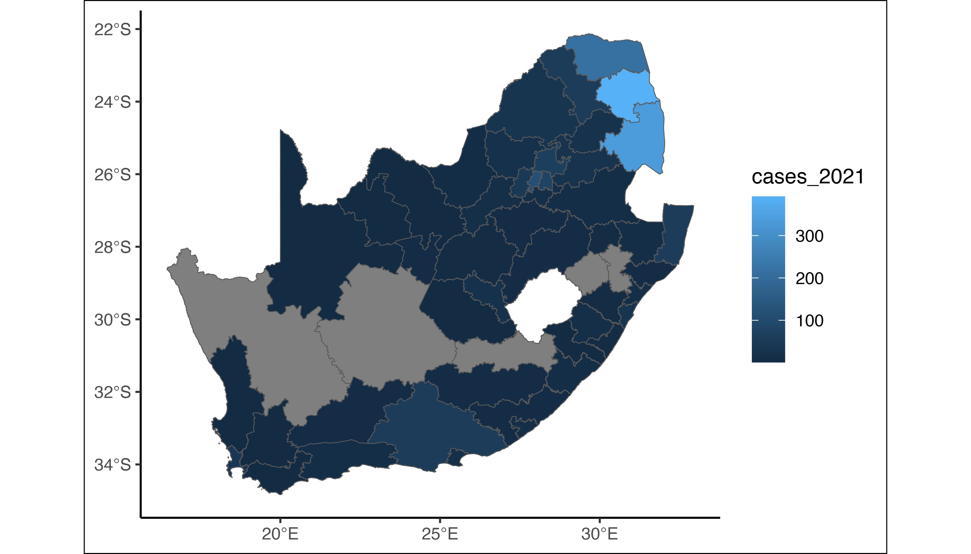

Figure 1.3: Choropleth map of Malaria cases in 2021

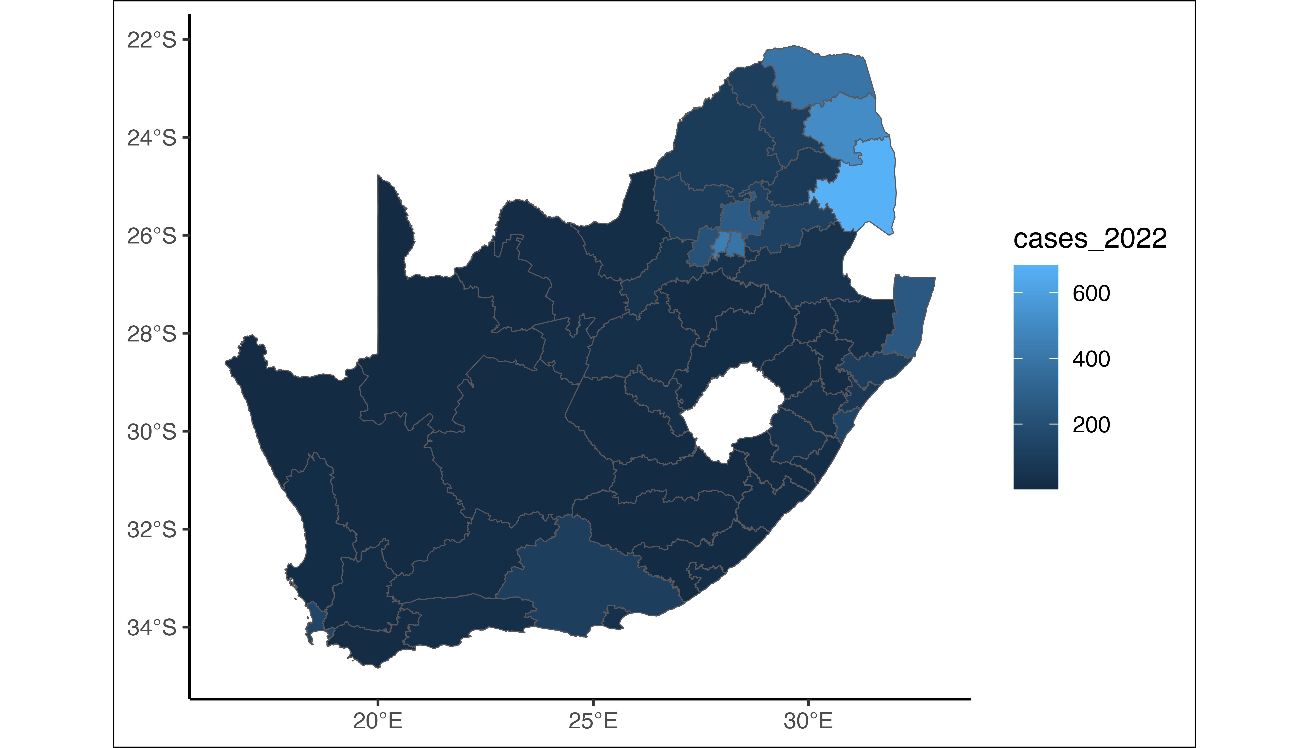

Figure 1.4: Choropleth map of Malaria cases in 2022

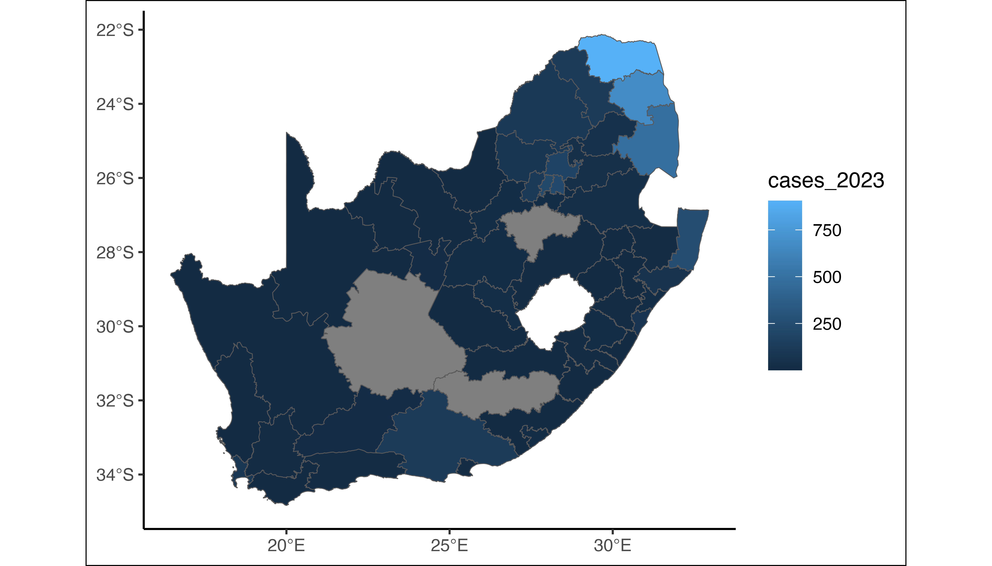

Figure 1.5: Choropleth map of Malaria cases in 2023

**END**